CSE370 : Database Systems
Assignment 01/02/03 | Spring 2026
ID : 23241004| Name : Afnan Mohammad Hafiz

No 1 Query  (as Plain Text) | create table runners(  student_id int,  student_name varchar(30),  email varchar(40),  distance_covered int,  time_taken_mins int  );
No 1 SS  (of Query & Output  in Shell) | 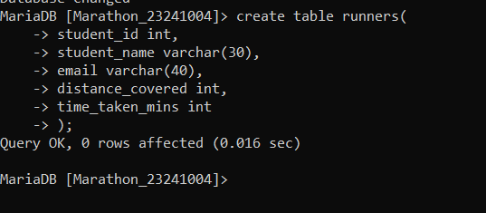
No 2 Query  (as Plain Text) | insert into runners values  (101, 'Mikasa Ackerman', 'mikasa.a@g.bracu.ac.bd', 5, 35),  (102, 'Edward Elric', 'e.elric@iub.ac.bd', 10, 59),  (103, 'Riza Hawkeye', 'riza.h@ewu.ac.bd', 5, 38),  (104, 'Bruce Wayne', 'b.wayne@g.bracu.ac.bd', 10, 63),  (105, 'Peter Parker', 'p.parker@iub.ac.bd', 5, 33),  (106, 'Alphonse Elric', 'a.elric@iub.ac.bd', 10, 55),  (107, 'Son Goku', 'son.goku@g.bracu.ac.bd', 5, 46),  (108, 'Gon Freecss', 'gon.f@g.bracu.ac.bd', 10, 68),  (109, 'Tanjiro Kamado', 'tanjiro.k@g.bracu.ac.bd', 5, 29),  (110, 'Roy Mustang', 'roy.m@ewu.ac.bd', 10, 83);
No 2 SS  (of Query & Output  in Shell) | 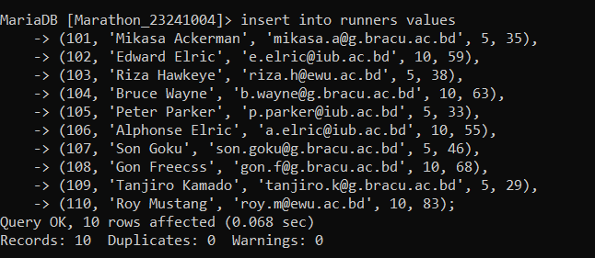
No 3 Query  (as Plain Text) | select * from runners  where distance_covered>6;
No 3 SS  (of Query & Output  in Shell) | 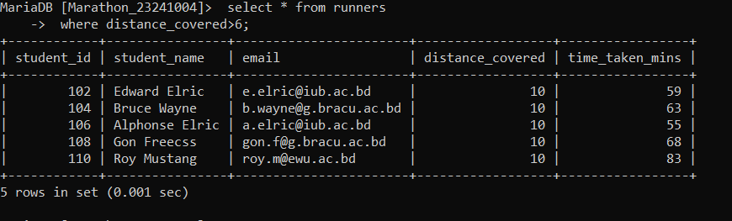
No 4 Query  (as Plain Text) | select upper(student_name)  from runners  order by time_taken_mins DESC;
No 4 SS  (of Query & Output  in Shell) | 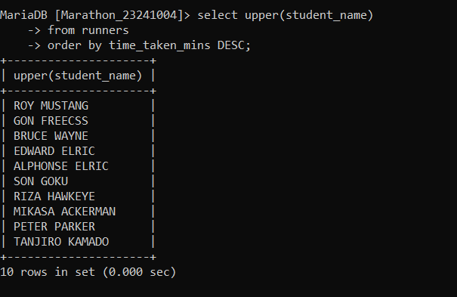
No 5 Query  (as Plain Text) | alter table runners  change distance_covered total_distance decimal(3,1);
No 5 SS  (of Query & Output  in Shell) | 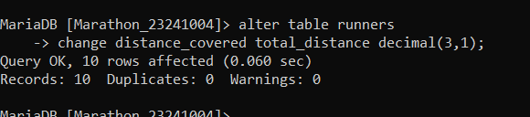
No 6 Query  (as Plain Text) | alter table runners  add kmh decimal(3,1);
No 6 SS  (of Query & Output  in Shell) | 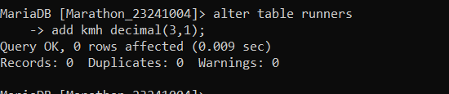
No 7 Query  (as Plain Text) | update runners  set kmh= (total_distance * 60) / time_taken_mins;
No 7 SS  (of Query & Output  in Shell) | 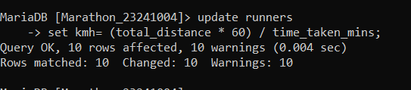
No 8 Query  (as Plain Text) | select (total_distance / 10) * (time_taken_mins / 60) * 100  as points, student_id, student_name, kmh  from runners;
No 8 SS  (of Query & Output  in Shell) | 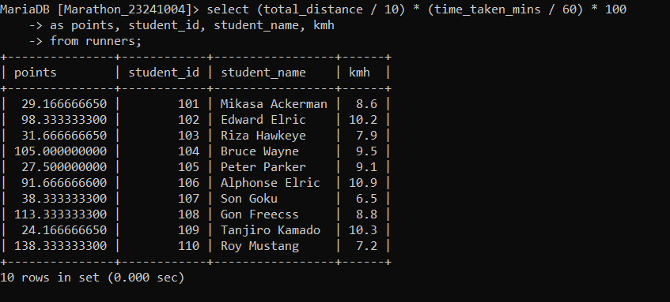
No 9 Query  (as Plain Text) | select student_name from runners  where total_distance=10 and time_taken_mins between 40 and 60;
No 9 SS  (of Query & Output  in Shell) | 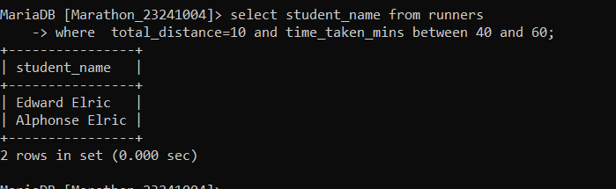
No 10 Query  (as Plain Text) | select student_name from runners  where email like '%@g.bracu.ac.bd';
No 10 SS  (of Query & Output  in Shell) | 